South Ribble Sports Development Mini Activities - MINDFULNESS
- Name of Game:  Challenge One: Lazy 8 Breathing  Finding some calmness | - Equipment required:  Card or piece of paper to draw an eight on big and clear.
- How to set up:  Sit up tall in a comfortable seated position.  Begin with your figure in the middle of the ‘eight’.  Go up to the left and trace the left part of the ‘eight’ with your finger while you breathe in.  Breathe out while you trace the right part of the ‘eight’ with your finger.  Sit quietly and notice eight breaths as you trace the ‘eight’ with you finger.  Steady yourself with your breath. | - The challenge and scoring:  Try eight to start, then increase as you go.  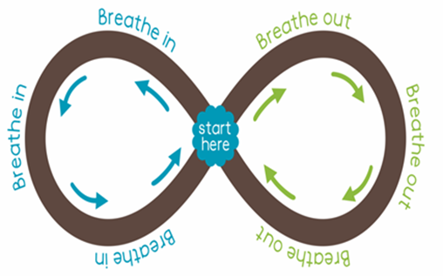
South Ribble Sports Development Mini Activities - MINDFULNESS
- Name of Game:  Challenge Two: Squeeze and Release  Finding some rest and relaxation | - Equipment required:  Mat or blanket to lie on.
- How to set up:  Lie down and close your eyes, take a few moments to notice your breathe.  Wiggle your toes, squeeze the muscles in your feet tight, hold and release. X3  Wiggle your fingers, squeeze the muscle in your hands tight, hold and release. X3  Notice your face, squeeze the muscle in your face, hold and release. X3  Lie still for a few breaths and let your body sink into the mat beneath you.  Rest for a few moments as long as feels good for you.  Letting go of any stress and discomfort. | - The challenge and scoring:  No need to score just rest and let go.  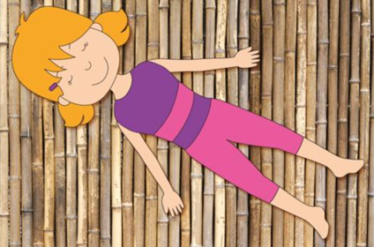

South Ribble Sports Development Mini Activities - MINDFULNESS
- Name of Game:  Challenge Three: Playtime Cat  Finding calmness through movement and stillness of your spine. | - Equipment required:  Yoga mat, blanket or gym mat to cushion knees and hands.  Fork, knife, plate or cup if you want to set your table for fun.
- How to set up:  1, Come onto your hands and knees with the tops of your feet on the floor. Making sure your hands are under your shoulders and knees directly beneath your hips. Back flat like a table, breathe in and out for five while imaging a table being set on your back. Hold a fork, knife, plate still on your back or set your table.  2, Lift your head and tail for cat “meow!”  Arch your spine and drop your head “Hisssss!”  Transition from a happy cat to a sad cat.  Stretch your spine and calm your wriggles. | - The challenge and scoring:  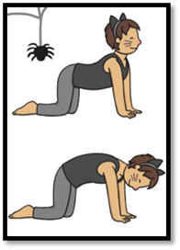  Cat Pose;  Happy Cat  Sad Cat
South Ribble Sports Development Mini Activities - MINDFULNESS
- Name of Game:  Challenge Four: Shake the Sillies Out  Finding some calmness through your wiggles | - Equipment required:  Yoga mat or blanket to lie on.
- How to set up:  Stand still like a statue. Notice your breath in and out for three breaths.  Shake out your arms, shake them high and low. X3  Shake out your legs, this way and that. X3  Shake your body until it’s loose, shake, shake, and shake your sillies away. See them fly off you like water droplets.  Gently come to a chair or lie on the floor, let out your last few sillies with an “Ahhhh!”  Take three deep breaths and rest peacefully for as long as you need.  Calm your wiggles. | - The challenge and scoring:  Try everything for three to start, then increase as you go. See if you can challenge to ten, then work back down again to three.  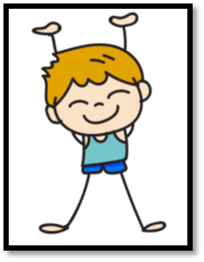
South Ribble Sports Development Mini Activities - MINDFULNESS
- Name of Game:  Challenge Five: Figure Eights  Loosen your muscles to help you relax your mind. | - Equipment required:  Just yourself on your feet and space.
- How to set up:  Stand with your feet apart and your arms up and out to the sides.  Keep your feet planted to the floor and twist your upper body side to side eight times.  Drop on arm and draw a figure eight in the air eight times. Swap arms.  Then use both arms, eight more figure eights, crisscrossing your arms in front.  Repeat the figure of eight with your upper body.  Let your arms go and take eight breaths.  Loosen up after doing hard work. | - The challenge and scoring:  8  Start the challenge with a count of eight, then increase as you go, each time you give it a try.

